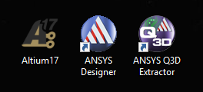
- Required software

Altium to Q3D
  - Exporting Altium PCB projects to ANSYS Q3D Extractor
The three programs that you need are:
- Altium Designer 17
- ANSYS Designer
- ANSYS Q3D Extractor
Previous versions of Altium will not have the proper exporting tools. Just ask IT to install ANSYS suit.
Starting with the PcbDoc in Altium (Fig. 2) place a board outline in one of the mechanical layers. In Fig. 3 the board outline is placed in layer Mechanical 15 which is shown in green. Mechanical 1 is usually used for 3D bodys—see caps and devices in Fig. 2—and I’ve put dimensions in the other standard Mechanical 13 layer.
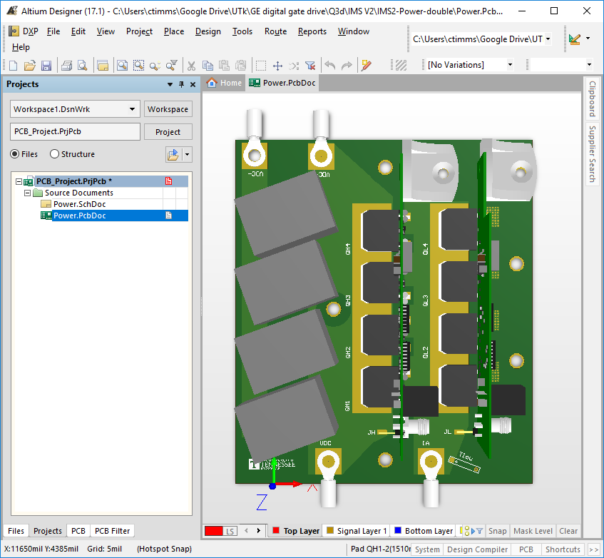 | 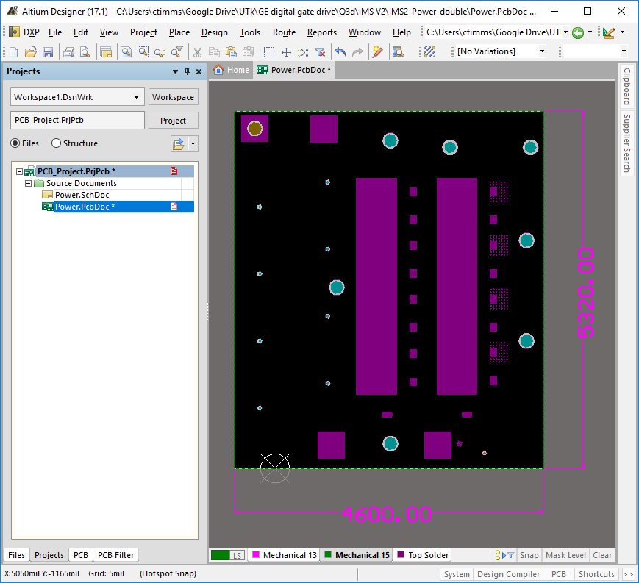
- PCB editor in Altium | - Board outline in Mechanical 15
Next export ODB++ file. The ODB++ file is a CAD-to-CAM data exchange format that is gaining popularity due to its superior efficiency compared to Gerber format (wiki).
 | 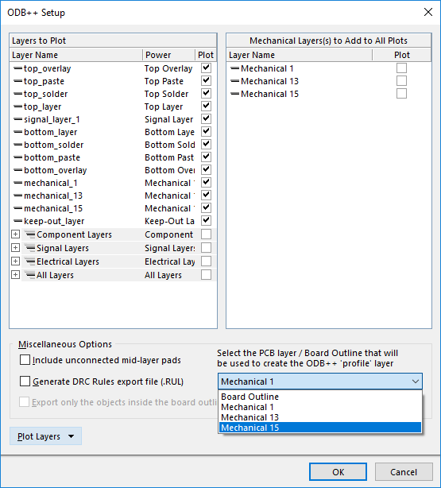
- Export via Fabrication Outputs | - Export dialogue box
Cam file pops up but not important, close without saving. In project folder there’s a new folder “Project Outputs for PCB_Project.” The guy that you want is the TGZ file—this is the ODB++ format. Note that it says it’s a compressed folder, that’s because it has all the good information.
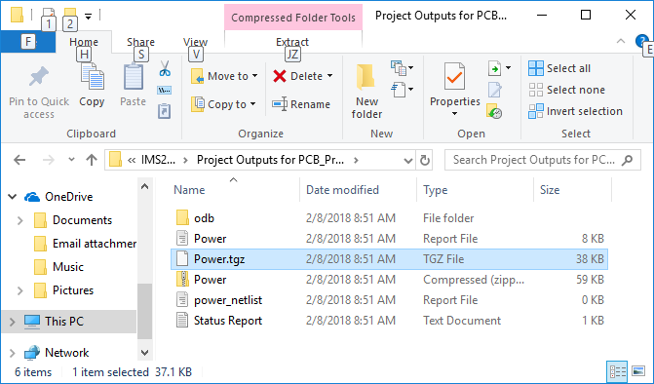
- Location of exported OBD++ file (.tgz)
Next open ANSYS Designer znd import your .tgz file. When the dialogue box pops up, select file as “archive type” then click Browse… button and find the .tgz file. A window pops up asking what nets to import, they all should be selected and hit OK.
 | 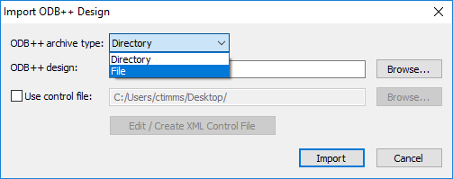
- Import OBD++ file to Designer | - Import dialogue box
After the import finishes, use the 3D exporter to convert to Q3D file type. Nothing should need to be changed in the dialogue box that pops up.
 | 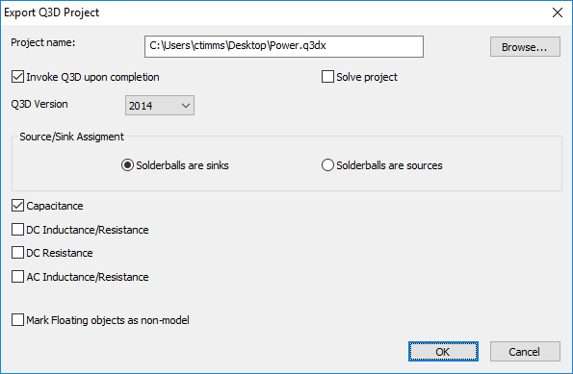
- 3d Export in ANSYS Designer | - Export to Q3D dialogue box
The desired Ansoft Q3D Extractor File (.q3dx) is now available in your working folder. If you didn’t check the Invoke Q3D upon completion box, Q3D extractor.
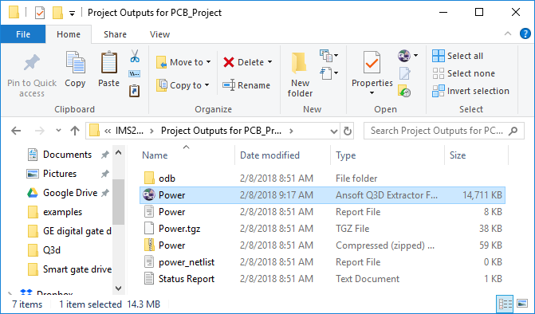 | 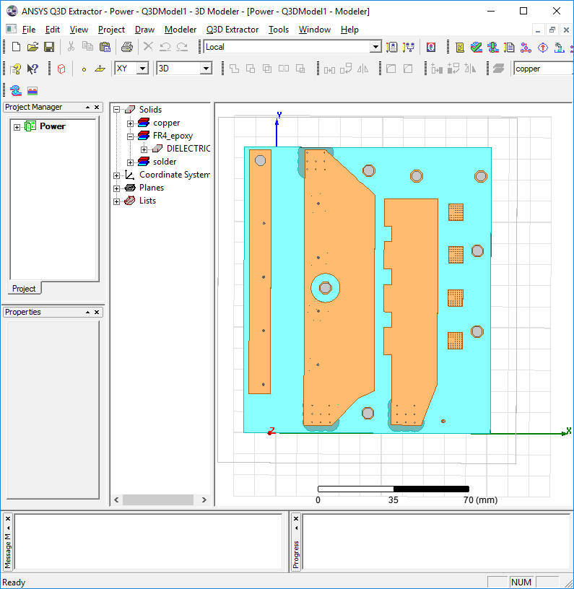
- Exported Ansoft Q3D Extractor File (.q3dx) | - What you’re looking for
For some reason the process outputs solder balls. Just select them all and hit delete.
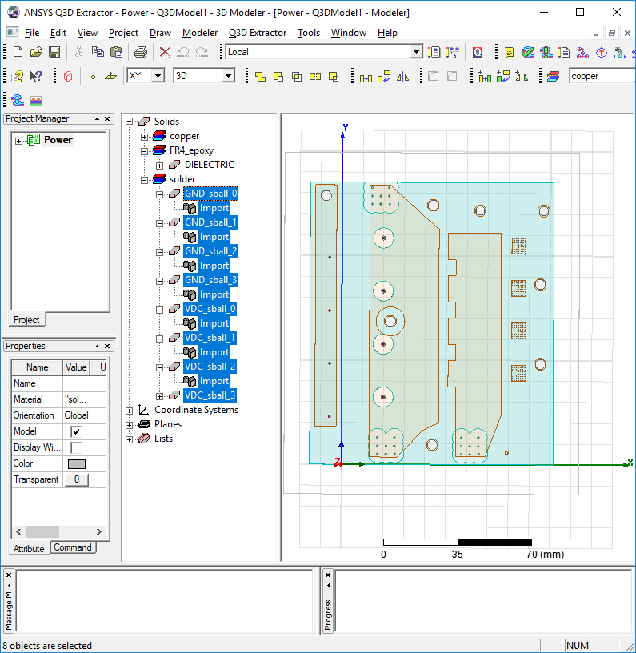
- Deleting solder balls

