Lesson Plan Template

Teacher: Jessica Minton
Grade/Subject: 6th/Science
Unit: Heat, Energy and Electricity
Lesson Title: Conversation of Energy
STATE STANDARD(S) | Identify what you want to teach. Reference State, Common Core, ACT College Readiness Standards, and/or State Competencies.
TN Grade 6 Science Standards:
GLE 0607.Inq.5: Communicate scientific understanding using descriptions, explanations, and models.
GLE 0607.10.2: Analyze various types of energy transformations.
GLE 0607.10.3: Explain the principles underlying the Law of Conservation of Energy.

LESSON OBJECTIVE | Clear, Specific, and Measurable – NOT ACTIVITIES  Student-Friendly: "The student will…"  Explicitly Stated for Students
The students will explain how energy is conserved with in a closed system.
The students will explain the law of conservation of energy.
The students will give examples of how thermal energy is always a result of energy conversion.
The students will explain why perpetual motion is impossible.

ASSESSMENT/EVALUATION | Measures Student Mastery In More Than Two Ways  Aligned with the Lesson Objective  Includes Measurable Formative and Summative Assessments  Requires Written Task
Students will be given a summative assessment at the end of the unit to collect data on understanding of the knowledge.
Students will be formatively assessed through the Question of the Day (Q.O.D.) over the previous material.
Students will be formatively assessed through the exit for the day when they write in their notebooks explaining the Law of Conservation of Energy.
Students will be orally assessed throughout the class when asked to explain about thermal energy and conservation of energy.

MATERIALS | Aligned with the Lesson Objective  Rigorous & Relevant
LCD Projector/Board with starting question, instructions, and procedures
Student’s Q.O.D. pages/Notebooks
Pencil/Pen
Layered Book
Homework Pages
Air pucks/playdoh/students hands

ACTIVATING STRATEGY | Hook  Essential Higher Order Question(s)  Activates Prior Knowledge  Real-World Connections
There is a Question of the Day (Q.O.D.) that will be on the board as soon as the students come in the door. Their questions: Where does the energy that makes a roller coaster move come from? Where does it go during the ride? And after the ride? Explain. (The questions and the answers will be written in their notebooks under the Q.O.D. section).

INSTRUCTIONAL PLAN | Step-by-Step Procedures and Times  Modeling Strategy – “I Do”  Planned Questioning (Knowledge/Comprehension, Application/Analysis, Creation/Evaluation)  Multiple Thinking and Problem Solving Strategies  Grouping Strategies  Differentiated Instructional Strategies to Provide Intervention & Extension
- Question of the Day: SEE ATTACHED. Where does the energy that makes a roller coaster move come from? Where does it go during the ride? And after the ride? Explain.
- Discussion of the Question of the day.
- Using the Conversion/Conservation PREZI, go over the information on the Law of Conservation of Energy, what it means to work within a closed system and why perpetual motion is not possible.
- Drinking Bird demo: See Attached.
- Air pucks and either playdoh (dropping) or “Indian burn” concept (students will rub hand together to cause friction that will cause their hands to heat up and give off thermal energy).
- Oral assessment/Exit Ticket end of class: In one sentence answer the following… The Law of Conservation of Energy is... Explain why it is important to energy.
- I will be walking around the room guiding the students and to be available for any questions/problems that might arise. (full class time)

GUIDED & INDEPENDENT PRACTICE | “We Do”-“You Do”  Student Work Encourages Higher Order Thinking & Problem Solving  Relevance to Students' Lives  Differentiated Strategies for Practice to Provide Intervention & Extension
Homework: Vocabulary and Section Summary: Attached.
CLOSURE | Reflection/Wrap-Up  Summarizing, Reflecting, Restating, Connecting  Provides for Student Engagement
In one sentence answer the following… The Law of Conservation of Energy is... Explain why it is important to energy.

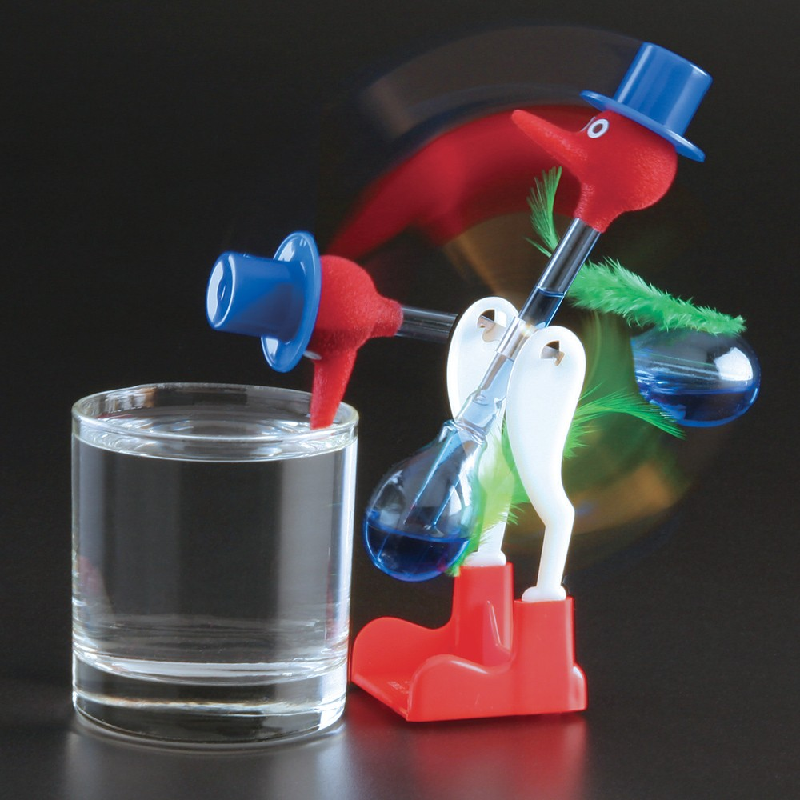
“Drinking Bird”

- When the bird “drinks,” the felt covering its head gets wet.

- When the bird is upright, water evaporates from the felt, which decreases the temperature and pressure in the head. Fluid is drawn up from the tail, where pressure is higher, and the bird tips downward.

- After the bird “drinks,” fluid returns to the tail, the bird flips upright, and the cycle repeats.

The bird cannot be an example of perpetual motion in a complete closed system…thermal energy from the air evaporates water from the bird’s head, which draws fluid up from the tail so the head tips down…the thermal energy used makes the “drinking bird” not in perpetual motion.

