Jessica Minton
Instructions:
- Get in groups of two.
- On your computer, go to the following link: http://engineering-games.net/engineering-games/67/energy-city
- Create your sustainable energy city and compare it to your partner’s city. Try to make your city as sustainable as you can.
- Work with your partner on one of your cities to create graphs or charts that break up your renewable and nonrenewable resources used in your city.
- Open the myDaq simulator from the USB drive.
- Look at the simulator to create patterns of load to solar output using the simulation.
- Describe the pros/cons of the system that you created with Energy City in writing. Be sure to use you background knowledge and justify your choice in the way you set up your city and the load scenario with the solar power simulation.
Materials:
- Computer with internet access
- LabView (on computers)
- myDaq usb drive
Purpose: This lab will highlight the need for using a balance of renewable and nonrenewable energy sources when improving the power grid. This will show guide them into thinking of the challenges that cities face when trying to incorporate renewable energy into their power grid, while still having them comprehend the need to switch to sustainable cities in the future.
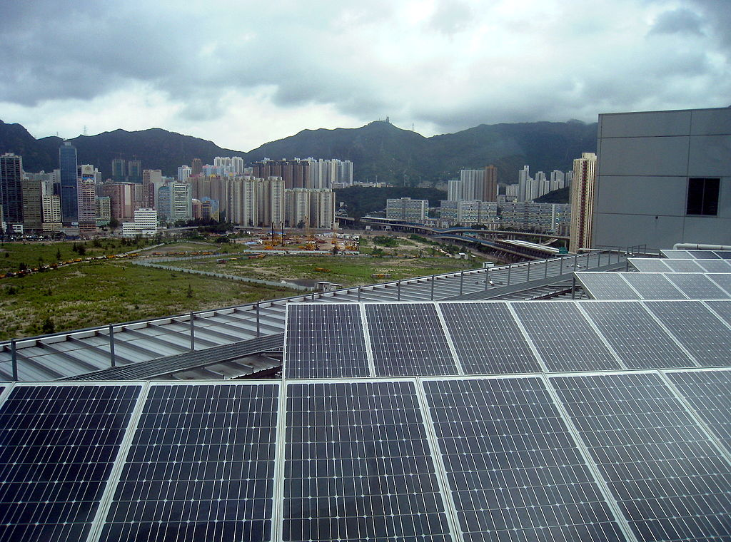x
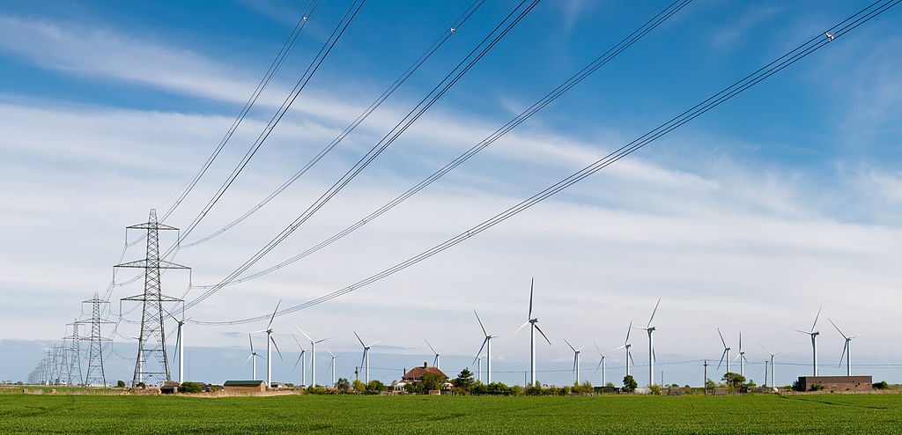x

