Signal Detection and

How to Build an Audio Amplifier

Rebecca Laughon – Homeschool

Derek Sprinz – University of Tennessee, Knoxville

**Abstract –**

**Signal detection is a phenomenon seen and used frequently in everyday life in radios, television, video games, radar, and electrochemical processes of living organisms. Oftentimes, such signals are miniscule and very difficult to detect with practical equipment. The amplification of a very small electrical signal can be used to allow the signal to be digitized with much greater precision. This is necessary to determine what the signal is and what it looks like. We propose in this paper a low-cost, ultra-low distortion, tunable gain signal amplifier for general purpose amplification in the 20Hz to 22kHz range. The design, simulation, and hardware testing of such an amplifier is presented.**

1. INTRODUCTION

Detection of signals is not as simple as it may seem. Many signals we wish to detect are extremely small, making it very difficult to determine what kind of signal it is and exactly what it looks like. An amplifier can increase the size of a signal, raising its amplitude such that it is measurable, and that its characteristics can be determined.

*Fig. 1. Sampled sinusoid before (black) and after (blue) amplification*

Figure 1. shows how the amplification of a signal can increase precision in signal quantizing and sampling. Note that the black sinusoidal curve vanishes when sampled (i.e. all samples are at level zero), but the amplified signal in blue is readily discernable when sampled.

A scenario in which amplifying a signal is necessary would be in a large auditorium. Someone is giving a speech, and the only remaining seats are in the backmost rows. The speaker’s voice cannot be heard very well from there, and their words are indistinguishable. An audio amplifier can remedy this, as shown in the following diagram,



*Fig. 2. Example diagram for audio signal amplification process*

Speaking into some form of receiver (a microphone), the receiver sends an electrical signal to an amplifier circuit. The circuit amplifies the signal, then passes it on to a speaker, which plays the signal as audio, much louder than before.

For our amplifier, our goal was to connect a microphone to an eight-ohm speaker with an output power of one watt. The following diagram illustrates the process more specifically,



*Fig. 3. Better-defined example of amplification process*

Using this information, we set about calculating the necessary characteristics of the amplifier to result in the one-watt output.

1. METHOD

To determine to source voltage, we looked up online the maximum output voltage of an average microphone, and found it to be equal to about forty millivolts [1]. To calculate the necessary output voltage from this, we used numerous mathematical formulas to create an equation that could be solved with the information we already had,

(Ohm’s law);

;

Once we had an equation that could tell us the desired voltage with our given information, we put the numbers in and solved for V2,

;

;

;

.

After calculating our voltages, we then determined the necessary gain of the amplifiers we were using to increase the input voltage of 40 mV (.04 V) to the output voltage of 2.8 V.

The formula for the gain of a voltage amplifier is as follows,

$$Gain=\frac{V_{out}}{V_{in}}$$

Putting the numbers in, we receive this as our gain,

$Gain=\frac{2.8 V}{.04 V}$;

$$Gain≈70$$

The amplifiers we would use in our circuit are called inverting amplifiers [2]. The specific formula for calculating the gain of such an amplifier is as follows,

$$Gain=\frac{V_{out}}{V_{in}}=-\frac{R_{2}}{R_{1}}$$

The configuration of an inverting op-amp in a circuit is shown in Figure 4.

*Fig. 4. Inverting op-amp*

To acquire a gain of positive 70 with the inverting amplifier components we were using, it was necessary to divide the amplifier portion of the circuit into two stages. Stage 1, with a gain of -10, would amplify the source voltage of 40 mV to -400 mV. Stage 2, with a gain of -7, would amplify Stage 1’s output of -400 mV to approximately 2.8 V.

LTspice is a software program that allows for the design and simulation of electrical circuits with risk of damage to any circuit elements [2]. After first drawing a draft on paper, we then reconstructed it in this program.

The following figure shows this design,



*Fig. 5. Draft design for amplifier circuit in LTspice*

After building the design in LTspice, we then ran a simulation on it and, after ensuring its functionality, began assembling the device on a breadboard as seen in Figure 6.

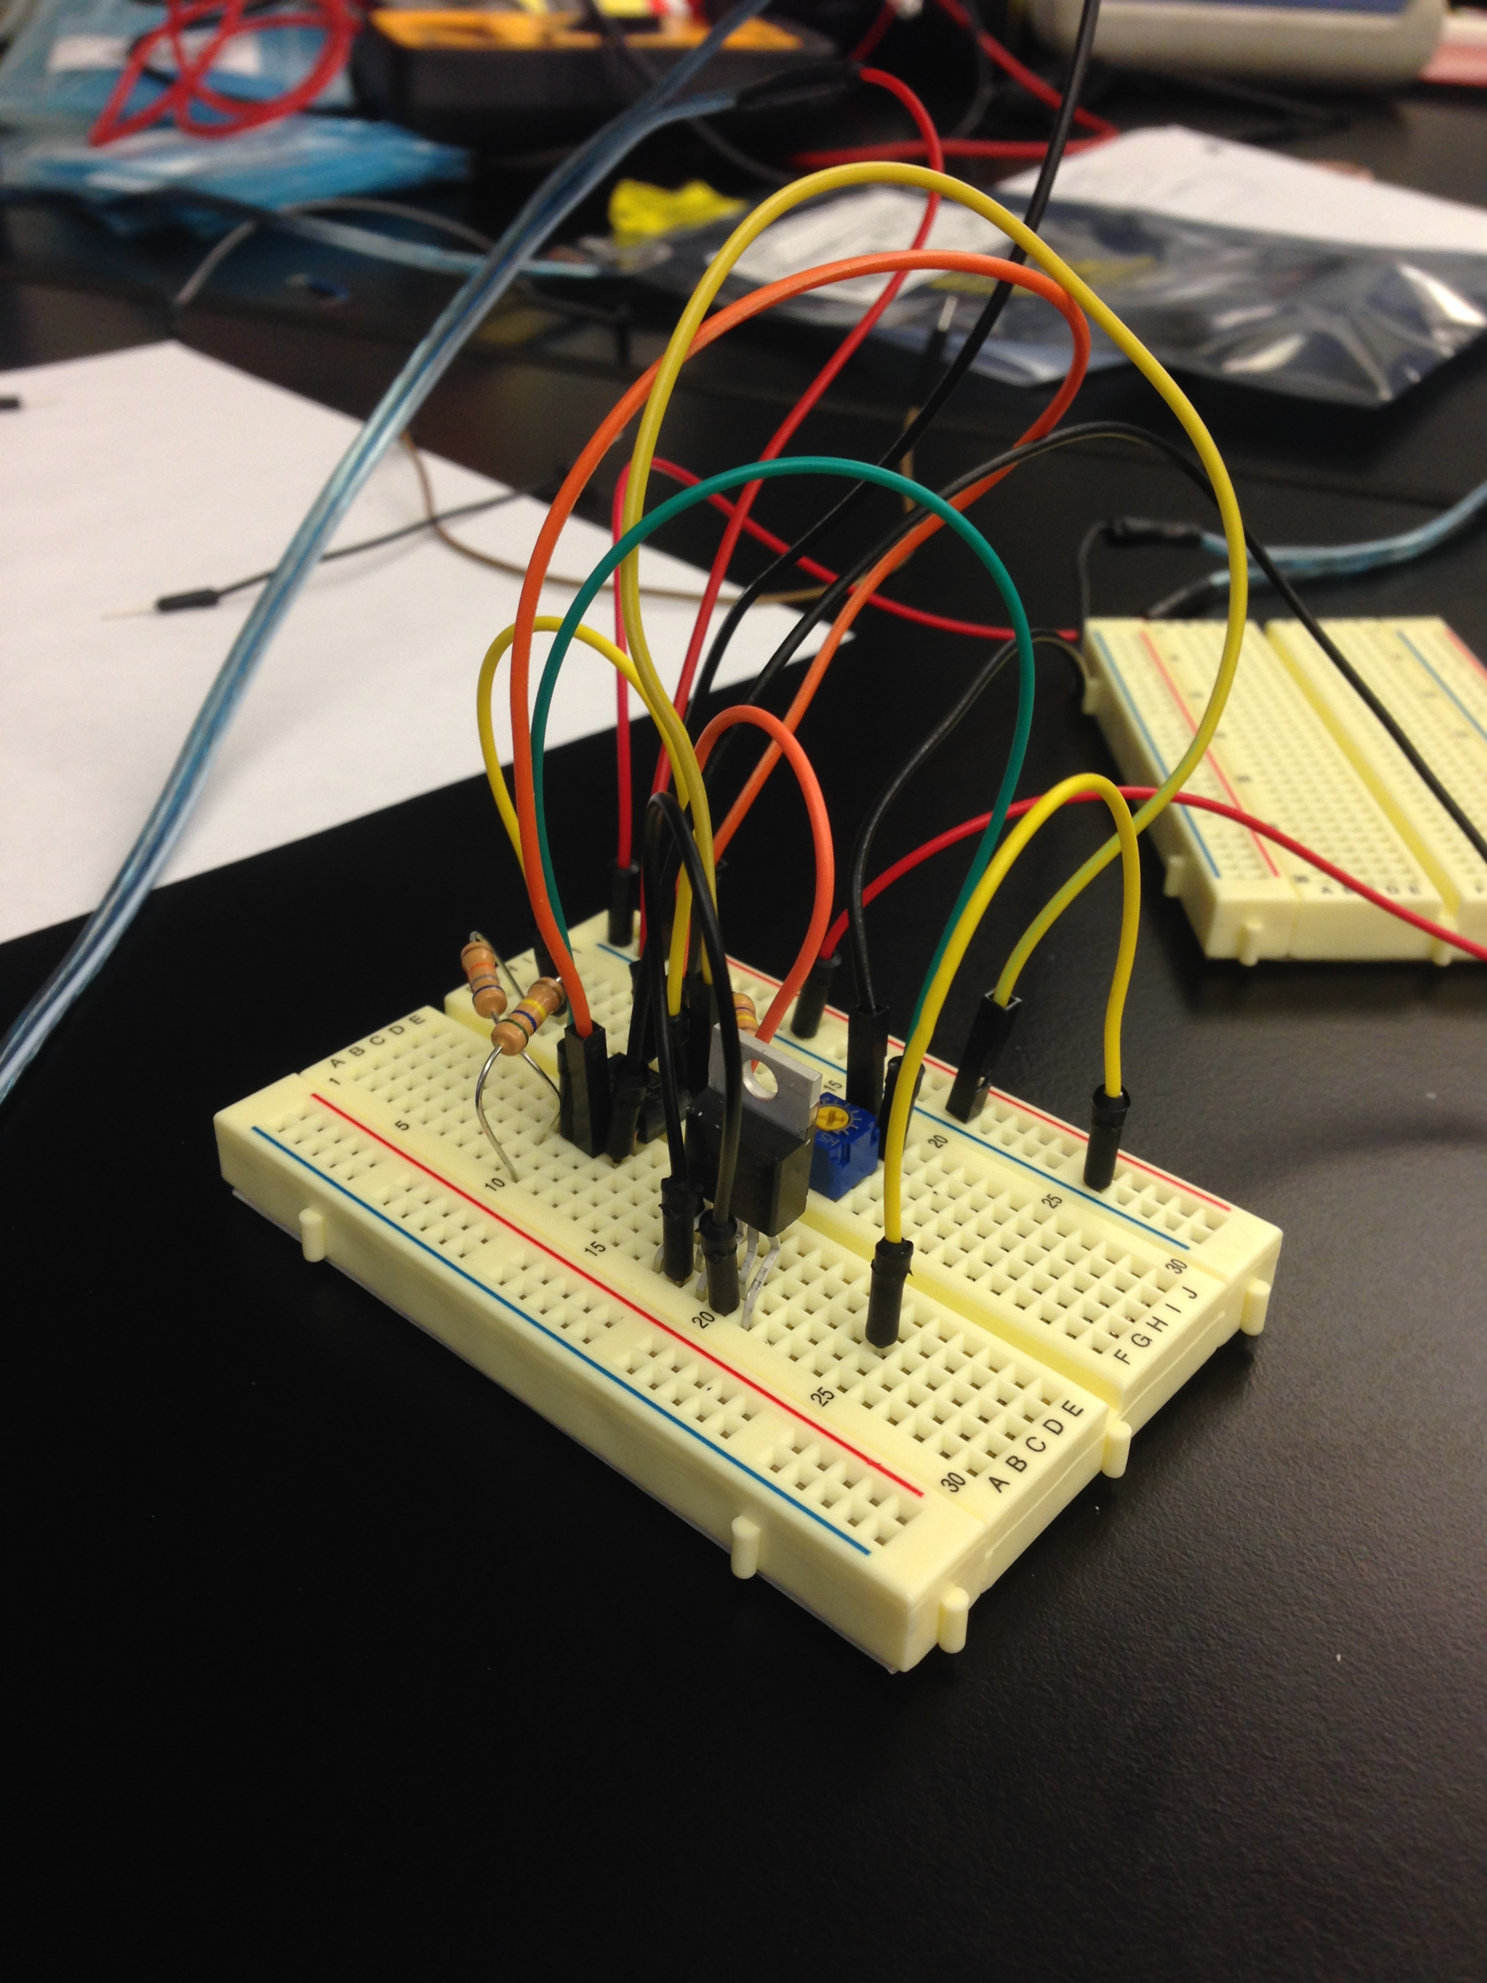

*Fig. 6. Breadboard implementation of amplifier with power op-amp*

While constructing the circuit we decided that, instead of a fixed gain of 70, we wanted the amplifier to have a variable gain. We accomplished this by replacing the first resistor in the circuit, labeled R1 in Figure 5., with a potentiometer.

1. RESULTS

A simulation was run on the circuit design in LTspice before the prototype was built, and gave the results displayed in Figure 7.



*Fig. 7. LTspice simulation voltage measurements*

The green line represents a measurement taken at the source voltage, a measure of 40 mV, or 0.04 V. The blue line shows a measurement taken at the output of the first amplifier stage with a gain of -10, a measure of -400 mV, or -0.4 V. The final measurement, the red line, was taken at the output of the second amplifier stage with a gain of -6.9, a measure of ≈2.8 V.

After running the simulation, we began building the amplifier. Connecting the voltage sources, the 8-ohm speaker, and a signal generator to the circuit, we were able to successfully play notes of various frequencies through the speaker, turning the dial on the potentiometer to raise and lower the volume. However, the power op-amp we used as an output buffer to drive current through the speaker was of poor quality, and created a large amount of extra noise. Removing the component and rewiring the other elements gave similar results, without the excess noise, but at the cost of increased distortion when the volume was turned up substantially.

The device without the power amplifier is shown in the following figure,

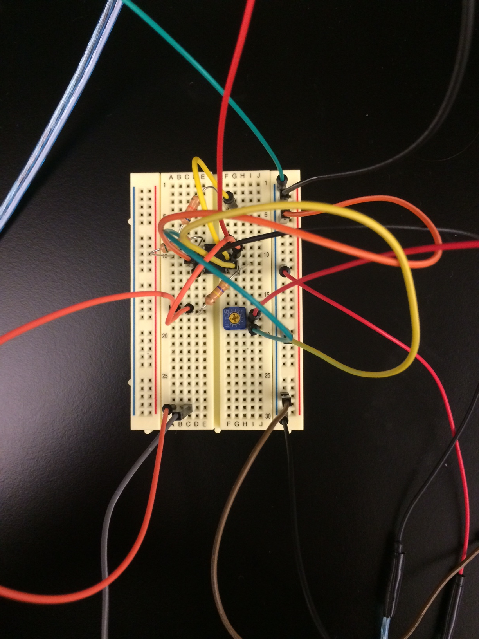

*Fig. 8. Breadboard implementation of amplifier without power op-amp*

Measuring the voltage at each stage output, we found them to be more or less consistent with those observed in the LTspice simulation shown in Figure 7.

1. CONCLUSION

Our initial objective was to design an inexpensive, high-current, low distortion amplifier circuit. We succeeded in this, but the use of a poor quality power op-amp resulted in too much extra noise being put through the speaker. Removal of the component eliminated the noise, but had the consequence of increased distortion when the volume on the speaker was turned up. Application of a higher quality op-amp would have yielded better results.

1. ACKNOWLEDGEMENTS

I would like to acknowledge and thank both Dr. Chen and Mr. Erin Wills for allowing me to partake in this Young Scholars Program. I’ve learned so much under the guidance of my mentor in only four weeks, and it’s been a fantastic experience working on this project.

This work was supported in part by the Engineering Research Center

Program of the National Science Foundation and the Department of Energy

under NSF Award Number EEC-1041877 and the CURENT Industry Partnership Program.

1. REFERENCES

[1] Smith, “Typical Microphone Output Level”, Clifton Laboratories, 05 March 2009.

[2] Dorf, Svoboda, *Introduction to Electric Circuits; 7th Edition*, Wiley 2006.

[3] Linear Technology, “LTspice IV Getting Started Guide”, 2011.