Survey of Power Transient Stability
Brazilian Blackout of 2009

Christine Garcia, Lenoir City High School & Blair Johnson, West High School
Dr. Jing Wang, Xinjiang University

Abstract
This paper offers a further insight on the stability of power systems, using a specific example of the Brazilian blackout of 2009. It includes the importance of power systems being transiently stable for many reasons that include cost and affected states in Brazil. Specifically this paper analyzes the failure of the circuit breakers in the system which cause a fluctuation in stability. An explanation of factors that can alter the results as well as modifications that could be added for future potential problems that can occur are included within this paper.

- INTRODUCTION
Public electricity began with six arc lamps in Rio de Janeiro in 1879. Today, Brazilian total electrical energy generation capacity is 117 GW, 72% hydraulic, 25% thermal, and 3% other (as of May 2010, according to the Brazilian Mine and Energy Department). There is still room for improvement within the stability of the power systems. The massive blackout affected not only 18 of Brazil’s 27 states, but also the entire population of Paraguay. São Paulo and Rio de Janeiro, Brazil’s two largest urban areas, were among hundreds of cities and towns that were unexpectedly plunged into darkness.
Blackouts affect so many different parts of life from just everyday television shows, to security, and even the economy because of the halt in production in factories. Faults in the power systems affect daily lives throughout the hoi polloi, as well as hospitals that need the electricity to perform common and surgical procedures. Having power outages in a popular location for tourism like Rio de Janeiro, is not good for the local businesses that thrive there. It is important to solve the problem of transient instability throughout not only the Brazilian Power System but every current power system as well as future systems.

- LITERATURE REVIEW
A power outage is a short- or long-term loss of the electric power to an area. There are many causes of power failures in an electricity network. Events that produce failures include damage to electric transmission lines, faults at power stations, substations, a short circuit, or the overloading of electricity mains. Institutions such as hospitals, sewage treatment plants, mines, and the like will usually have backup power sources such as standby generators, which will automatically start up when electrical power is lost. A permanent fault is a massive loss of power typically caused by a fault on a power line. Power is automatically restored once the fault is cleared.

- METHOD
The first step in our project was to research the major blackout that occurred in Brazil on Nov. 10, 2009. We spent several days researching the events of this blackout and what the causes of these events were. We also spent several days familiarizing ourselves with the different parts of the power grid, the basics of power generation, and how the transmission system operates. The next step in our project was to familiarize ourselves with Simulink, a Matlab plugin that we would be working with in the final project. Dr. Wang assigned us simple practice circuits for homework, and we played around with the example projects available through the help menu.
We then transitioned into a period of preparing for the final model. We learned about load angle, and practiced making power systems with synchronous machines inside Simulink. The next step in the process was to begin the final model. Dr. Wang gave us a diagram of the power system we were supposed to model, and we set to work. We laid out a synchronous machine, transformers, breakers, transmission lines, scopes, the fault and an infinite power source to simulate the rest of the Brazilian grid. Then we worked on setting parameters. Our mentor helped us set the correct parameters and debug the system. The final step in the process was to conduct our simulations. We first simulated the system without any faults in the transmission lines. The second simulation we ran included a two phase fault on the transmission lines, but had breakers which were set to open in 0.07 seconds- 0.14 seconds faster than the actual breakers. We ran the final test with the breakers opening in 0.21 seconds, the time it took in the actual blackout. In addition to taking readings for power and load angle δ, we also placed current and voltage sensors around the system so that we could monitor the flow of energy throughout our tests.
- RESULTS
The first set of results we recorded represent a stable power system. These results were recorded when running the simulation without faults in the transmission lines.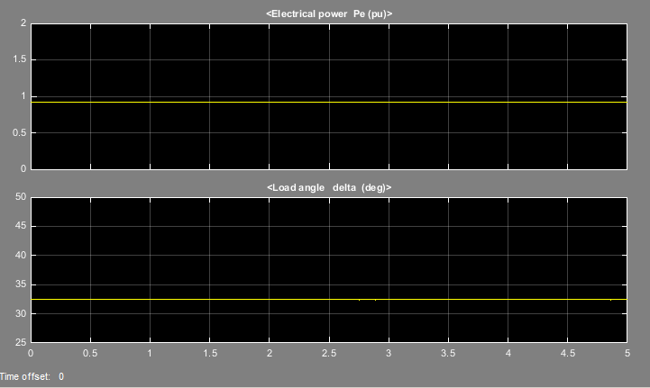

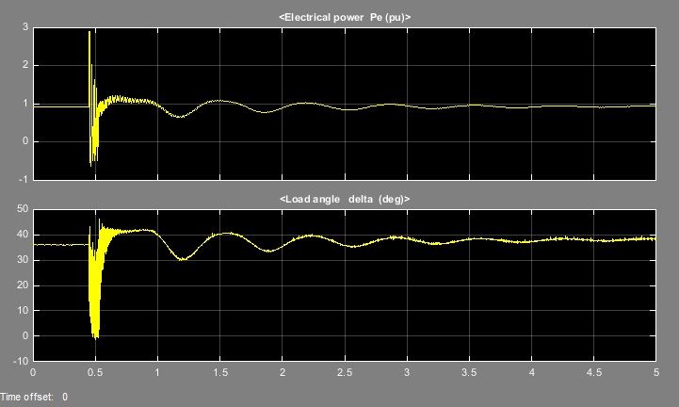
The second set of results we recorded were generated by triggering an AB-Ground fault at 0.45s and opening the breakers at 0.52s.
The final set of results were generated by triggering an AB-Ground fault at 0.45s and opening the breakers at 0.66s
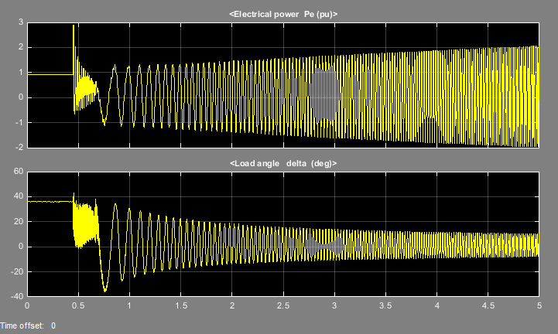

- DISCUSSION
Analysis of transient instability is very important due to the fact that modeling a system and potential faults can help power systems engineers understand the limits of the power system. The first simulation exhibited stability. Due to the lack of a fault, the power system did not show fluctuation in power or load angle. The second test found the breakers opening 0.53 seconds into the simulation- 0.08s after the initial fault. The simulation showed three distinct stages. The initial period from the start of the simulation (0 sec) until the fault (.45 sec) exhibited stability. At 0.45 seconds the power and load angle began to sporadically spike and fall up until 0.53 seconds. After 0.53 seconds (the point at which the breakers opened) the instability began to decrease; the system was stable by the end of the simulation. In the final test the same three stages were exhibited. The system was stable until the time of the fault. After 0.45 seconds the system showed great fluctuation in both power and load angle. These spikes slowed down after the opening of the breaker at 0.66 seconds, and they continued to increase in amplitude as time progressed.
- CONCLUSION

Engineers use programs like Simulink to model systems to insure their stability and efficiency before placing the fate of the grid on that system. In addition, transient stability studies are needed to ensure the greater power system can withstand the transient instability produced by a major disturbance. Engineers will need to devise new methods for keeping a power system’s load angle delta stable, even in the event of increased load or a fault. This will help a grid remain, or regain stability after a major event such as a shorted transmission line, or load spike. The blackout in Brazil also highlights the importance of keeping a power system up to date, and regularly inspecting equipment to ensure that it is functioning as effectively as possible. Had such measures been taken, the slow breakers on the shorted transmission lines may have closed in time to prevent the massive instability that triggered the blackout.

ACKNOWLEDGEMENTS
This work was supported in part by the Engineering Research Center Program of the National Science Foundation and the Department of Energy under NSF Award Number EEC-1041877 and the CURENT Industry Partnership Program.
My mom, my dad, Albert Einstein, Jesus Christ, Richard Dawkins, the moon, Gabe Newell, Tom Robinson, the green teletubby, Uncle John, Jim Crow, Monica Lewinsky, Chris Pratt, Muhammad Ali, Steve Wozniak, my neighbors dog Fluffy, all my loyal instagram followers, my second cousin Ben, my psychiatrist, and all the friendly people at the local bowling alley.
-for your support and dedication, we thank you.

REFERENCES
Conti, J. P. "The day the samba stopped [power blackouts]." Engineering & Technology 5.4
(2010): 46-47.

http://science.howstuffworks.com/environmental/energy/blackout.htm

http://www.wisconsinpublicservice.com/home/power_occur.aspx

