Monitoring Blood Glucose Concentration Levels for Diabetes Using LabView

Diane Kim, Farragut High School
Peixing Liu, University of Tennessee

Diabetes mellitus, otherwise known as diabetes, is a group of metabolic diseases that strikes up to 30 million people in the United States (1). It is caused either by the pancreas being unable to produce insulin or by the cells not responding properly to the insulin produced. Two types of diabetes are most typical in the United States: Type 1 and Type 2. Both types face issues with blood glucose levels. In order to manage this illness, patients must manually check their insulin levels periodically throughout the day. This is done through blood glucose meters – the patient must prick his finger, and then place the drop of blood on a test strip to insert into the device and read the blood glucose level. More recently, sensors that can be placed under a patient’s skin have been developed. This allows the patient to measure glucose levels without having to prick his finger multiple times throughout the day, avoiding pain and possibility of infection. My program is designed to e the slope between frequencies given off from a particular biomedical device connected to the patient and the correlating blood glucose level. With the slope, the program is able to then calculate the missing variable – the current blood glucose level.
- INTRODUCTION
Two types of diabetes are most frequent throughout the diabetic population. Gestational diabetes, a third type, happens frequently during pregnancies. (Blood sugar usually returns to normal levels soon after birth.) Type 1 diabetes mellitus is usually diagnosed at an early age, and is significantly more rare than Type 2; only 5% of the United States’ diabetic population is diagnosed. It is characterized by the loss of beta cells, which produce insulin in the pancreas. The insulin is a “key” for liver, muscle, and fat tissue cells. It opens the cells to take up glucose from blood and convert it into glycogen, which can be stored in the liver and muscles. This glucose is also the energy for the cells to perform their proper functions. Without the insulin, the cell is unable to open up, creating a blockade and preventing cells from taking in the necessary glucose and functioning normally.
Known in the past as “brittle diabetes”, Type 1 causes dramatic fluctuations in glucose levels, inducing symptoms such as infection, gastroparesis, and endocrinopathies. Multiple genes, as well as certain Human Leukocyte Antigen genotypes, take part in causing Type 1 diabetes, leading it to be partially hereditary. The strongest gene, IDDM1, is located on chromosome 6. Definitive causes are unknown, obstructing the path to finding a cure. Though the diabetes may not be prominent in one’s body at first, certain environmental aspects can trigger it, such as dietary habits or viral infections. Some chemicals destroy pancreatic cells, such as a rodent poison (Pyrinuron). One theory proposes when the immune system attacks virus-infected cells, it also attacks the beta cells, destroying them regardless viral infection. Other factors, such as tumors, pancreatitis, and trauma, can also lead to disruptions in insulin production.
Type 2 diabetes is far more widespread, affecting 90% of the United States’ diabetic population (2). Though genes play a role in causing this disease, it is often preventable; certain lifestyles consisting of poor diet and little to no exercise can make one susceptible to Type 2. Being obese puts one at significant risk for developing Type 2, as 4 out of 5 people with it are extremely overweight. This is in part due to the excess fat – fat brings about a mild inflammation in the body that contributes to both heart disease and diabetes (3). The excess fat also affects the way one’s body responds to insulin, leading to insulin resistance. This develops because a person’s body may not be producing enough insulin for their needs, so the glucose is trapped outside of the cells, remaining in the bloodstream. This causes high blood glucose levels, leading to diabetes. The cells, despite the insulin in the bloodstream, don’t allow enough of the glucose into the cells, therefore causing the “insulin resistance” (4). As this condition progresses, a lack of insulin may also develop. Because of the preexisting disease that led to diabetes, this form of diabetes mellitus was previously referred to as “non insulin-dependent diabetes mellitus” or “adult-onset diabetes”.

- LITERATURE REVIEW
To measure blood glucose levels, the patient must use some type of biomedical device; today’s monitors include finger pricking or body sensors (5). They are quantitative tests that focus solely on the amount of glucose present in the patient’s blood. The finger pricking method is most often used among those diagnosed, and consists of a test strip and a device to insert the strip into to read the glucose levels. The patient must prick his finger and place a drop of blood onto a test strip. The monitor would be calibrated to the type of test strip it measures, affirming accuracy. Another method utilizing the test strip would be a non-meter test strip that changes colors depending on the amount of glucose in the patient’s blood. Though not as accurate as a monitor, it is just as effective, alerting the patient if levels are dangerously extreme. One technological device that is non-invasive is the GlucoTrack, a device attached to the patient’s earlobe. However efficient and practical this may seem, it has yet to be approved by the FDA and is currently only available in Europe. In the near future, though, the U. S. hopes to implement this device into everyday use for diabetics.
The latest technology for measurement is a Continuous Glucose Monitor (CGM). This device tracks the patient’s glucose levels consistently throughout the day and night, typically collecting data every five minutes. The CGM requires a tiny sensor to be placed under the skin of the patient’s belly, and measures the level of glucose in the fluid inside the body. However practical this may seem, the CGM does not replace traditional glucose monitors. The patient will still need to measure their blood glucose levels with a monitor a few times a day to maintain accurate readings.
The technology that I developed is based on the monitors used today; however, my methods would allow production of cheaper, more affordable devices. This is in part due to the simplicity of the program – rather than taking in multiple biological factors at once, the program uses two components and measures a slope between two individual pairs. In doing so, it ensures accuracy while lessening the energy input necessary.

- METHOD
LabView is a visual programming software that allows the user to develop systems using icons and graphics. It consists of a block diagram, which is where the user develops the program and edits details, and the front panel, which is what the consumer will see when using the program. I began by using a Data Acquisition Card, otherwise known as a DAQCard, which acquired data from a waveform generator. This generator simulated signals that would otherwise be given off by a hospital patient, allowing us to work from a lab rather than commuting to a hospital every day. However, after a few days, using the waveform generator and DAQCard became obsolete when I discovered a “Simulate Signal” function that came with the LabView program, which simulated signals similar to that of a waveform generator. This data would be transferred to a waveform graph, which was displayed on the front panel.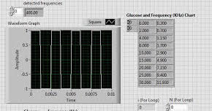
Fig. 1: Waveform graph that displays received data
Because my method included taking frequencies from a biomedical device and pairing it with various glucose levels, I used an “Extract Single Tone Information” function that allowed me to extract the frequencies data given off from the simulations. In doing so, I created an indicator that showed the varying frequencies on the front panel for the patient to view. My mentor sent me data sheets of correlating glucose levels and frequencies to begin my project; these previously measured correlations guaranteed accuracy from my program. By using data extraction and “Read From Text” functions, I was able to convert text files from my computer onto the program itself and utilize the information. Because there were 9 pairs of correlations, I placed the entire program with a For Loop function, which repeated the process eight times for the benefit of the patient. This allowed the program to perform separate calculations for each individual sets of pairs, giving the most accurate information for the patient and doctor. The front panel provides options for different text files, allowing the user to insert different text files based on different sets of data (see figure 2).
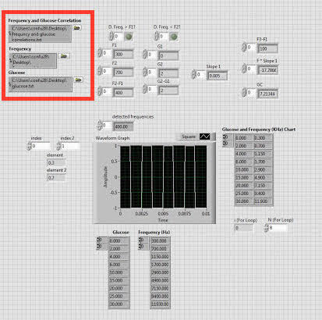

Fig. 2: The front panel allows the user to choose which text files to utilize within the program.

From the text files, after they were converted for LabView use, I then programmed a calculation method that would find the slope between two pairs of frequencies and glucose concentrations.
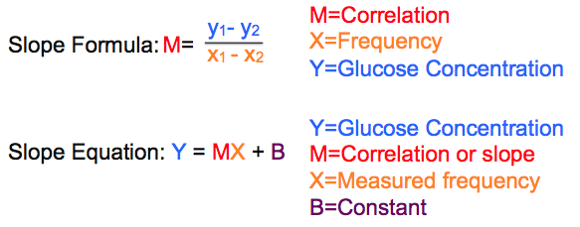
Fig. 3: Equations used and what the variables stand for.
Because the blood glucose levels need to be within a certain range to be considered normal, alarms were necessary to notify the patient in times of instability. I set the program to only perform certain steps if the received data fit within that specified range; if it didn’t, the program would notify the patient through certain LED signals. In the case of my program, the LED signals were implemented within the front panel.
The calculation itself was placed within a Case Structure. A Case Structure only performs the functions if the received data is “true” or “false”. If it is true, the function is performed, and the signal on the front panel will light up. If false, the function does not perform, and the front panel signal will not light up, signifying a danger in glucose levels.
Fig. 4: Block diagram; annotations indicate the range setting

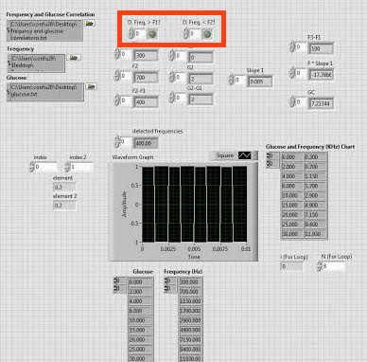
Fig. 5: Front panel; annotation indicates the signal that would notify the patient

The notification signals are vital to the efficiency of this program because it will instantly notify the patient or those surrounding the patient if there are any dangerous levels within the patient.

- RESULTS
Though I have no data to present (due to my project focusing on programming), my results are that newer programs can be used to save costs of devices and help patients. The simplicity of the program demonstrates efficiency to a high extent, and in the near future, can be simplified even further to achieve high proficiencies while still maintaining accuracy and practicalities.

- CONCLUSION
From this program, I have learned how to use LabView and its purpose for electrical engineering; it is an effective system that will serve its purpose in a straightforward fashion.
My work proved to be beneficial because of the simplicity, as emphasized before. By using the power of electrical engineering, the process of extracting biomedical data and applying it to technology that will convert it to a readable number can be used on the most convenient of monitors. It will ensure an easier lifestyle for those diagnosed with both Type 1 and Type 2 diabetes, as its utilitarian function will be further improved in the next few years.

ACKNOWLEDGEMENTS
This work was supported in part by the Engineering Research Center Program of the National Science Foundation and the Department of Energy under NSF Award Number EEC-1041877 and the CURENT Industry Partnership Program. I would also like to thank my mentor, Peixing Liu, for being a tremendous help with the entire process. I also owe thanks to Dr. Chen and Mr. Wills, who were both caring and encouraging throughout the entirety of the program.

REFERENCES
"Best Blood Glucose Meters." Best Blood Glucose Meter Reviews – Consumer Reports. Consumer Reports, n.d. Web. 24 July 2015.

"The Not-So-Sweet Facts of Diabetes." Healthline. N.p., n.d. Web. 24 July 2015.

"What Causes Type 2 Diabetes?" EverydayHealth.com. N.p., n.d. Web. 24 July 2015.

"What Is Insulin Resistance?" What Is Insulin Resistance? Joslin Diabetes Center, n.d. Web. 24 July 2015.

