Eric Stansberry
Instructions:
- Go to http://phet.colorado.edu/simulations/sims.php?sim=Faradays_Electromagnetic_Lab
- Start the simulation by clicking download, and then click run.
- Move the bar magnet around the compass and see how the strength and direction of the magnetic field changes.
- Open the electromagnet tab and repeat the previous step with the electromagnet. Move the switch on the battery to change the voltage and observe what happens.
- Change the battery type to AC using the panel on the side and observe how the magnet works.
- Complete the lab manual questions.
Materials:
- Computer
- Faraday’s Electromagnetic Lab program
- Lab Questions Worksheet
Purpose:
Students will learn how magnetism works, and how electricity can be used to create a magnetic field that can be harnessed for other functions.

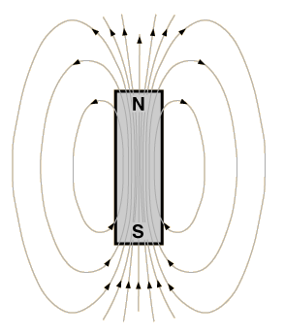
https://commons.wikimedia.org/wiki/File:Barmagnet1.png
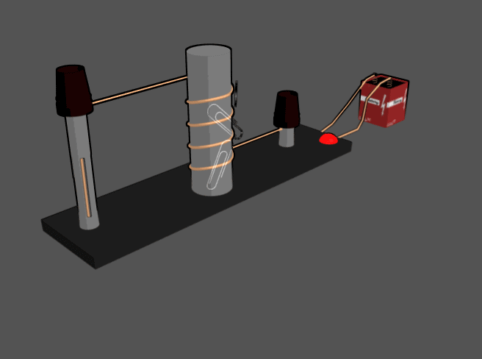
https://commons.wikimedia.org/wiki/File:Electromagnet.gif

Name:

Questions

1. Using diagrams and written explanation, explain the magnetic field direction and strength around a bar magnet and an electromagnet. (40 points)

2. Explain the similarities and differences of a bar magnet and an electromagnet. (30 points)

3. Identify the characteristics of electromagnets that are variable (can be changed) and what effects each variable has on the magnetic field’s strength and direction. (30 points)

